Instructions to Apply for tender with nomeclatures

In order to apply for E-Tender, company needs to be registered on procurement web-page www.tenders.ge

E-Tender consists of 5 informational tabs.
- Description
- Questions
- Proposal
- Results
- Messages

1. Description

In the description tab you can find short information about the tender content and requirements. Full tender documentation can be downloaded from the attached files at the bottom of the announcement text.

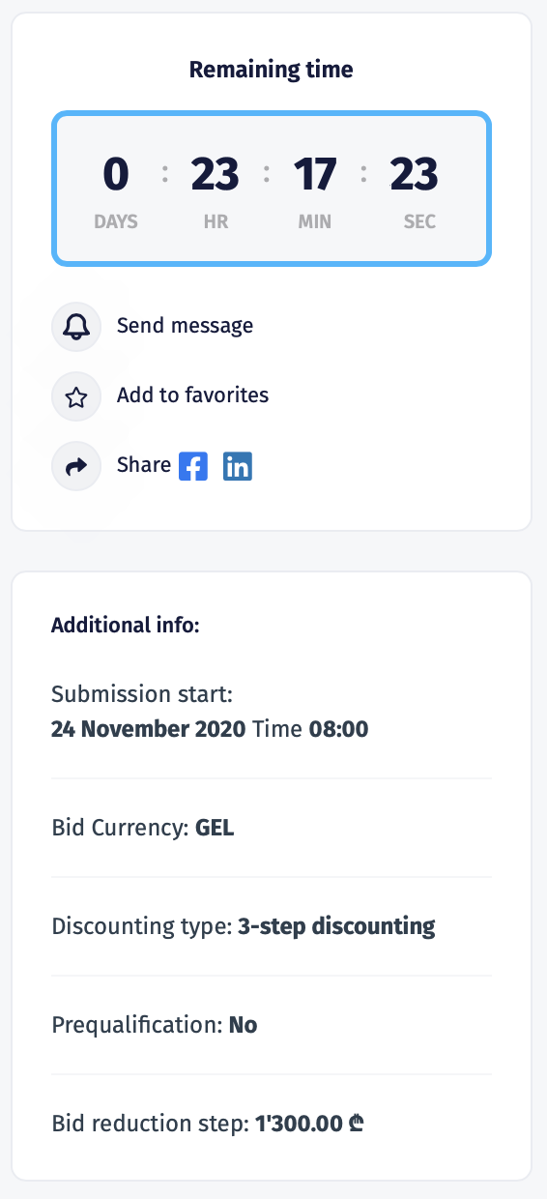 | On the right side of the page you can view the counter that shows deadline of submitting the offer for the current tender.  Additional information shows:  - Bid submission start time;  - Bid Currency  - Discounting Type: No Discounting, 3 Step Discounting, Reverse/Forward Discounting;  - Prequalification option;  - Bid reduction Step (If discounting is enabled).  - Max/Min Bid Ammount (If required)

2. Questions

In the following tab companies have possibility to ask questions directly to the procurer representative and receive the answer in the system. In order to use the following tab, user needs to be signed in. Questions asked by the company as well as the received answers are visible for all users, however the author of the question is hidden even for the procurer.
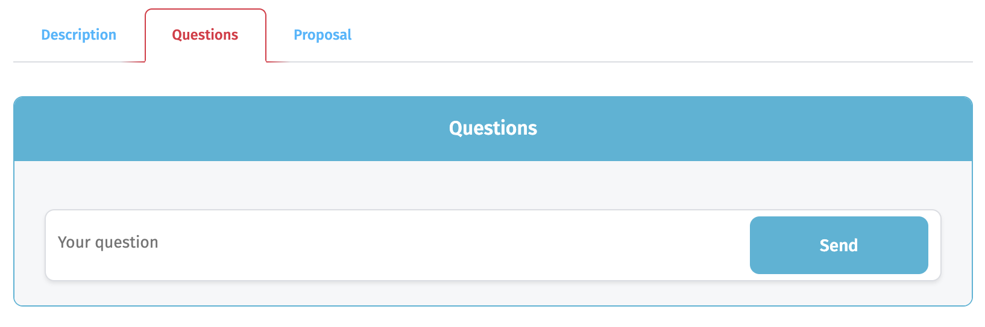

3. Proposal

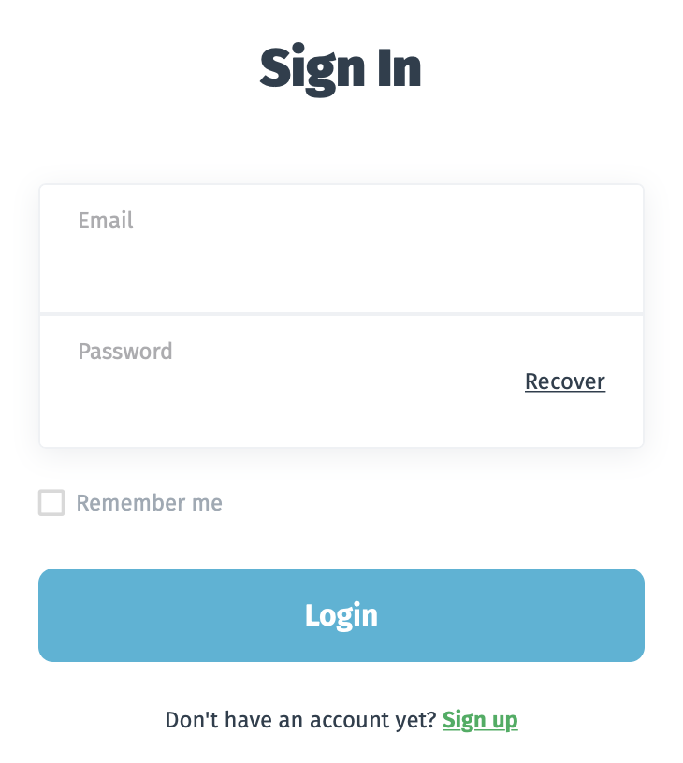 | In order to apply for the tender, user should be signed in. In case your company is not registed on our web-page, please proceed with “Sign Up” button.
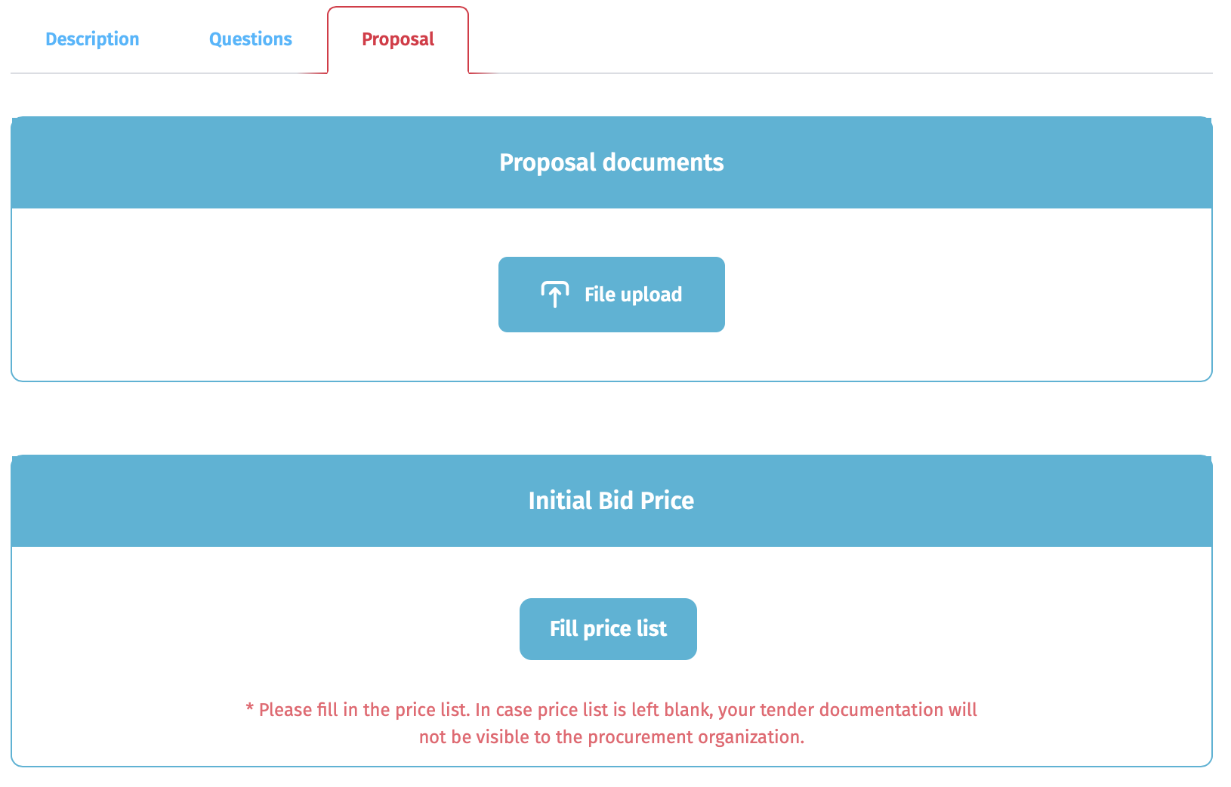 | After signing in, you can upload your offer from the “Proposal” tab.  Note: Uploading the documentation is not mandatory, however the bid must be submitted by pressing “Fill price list” button.
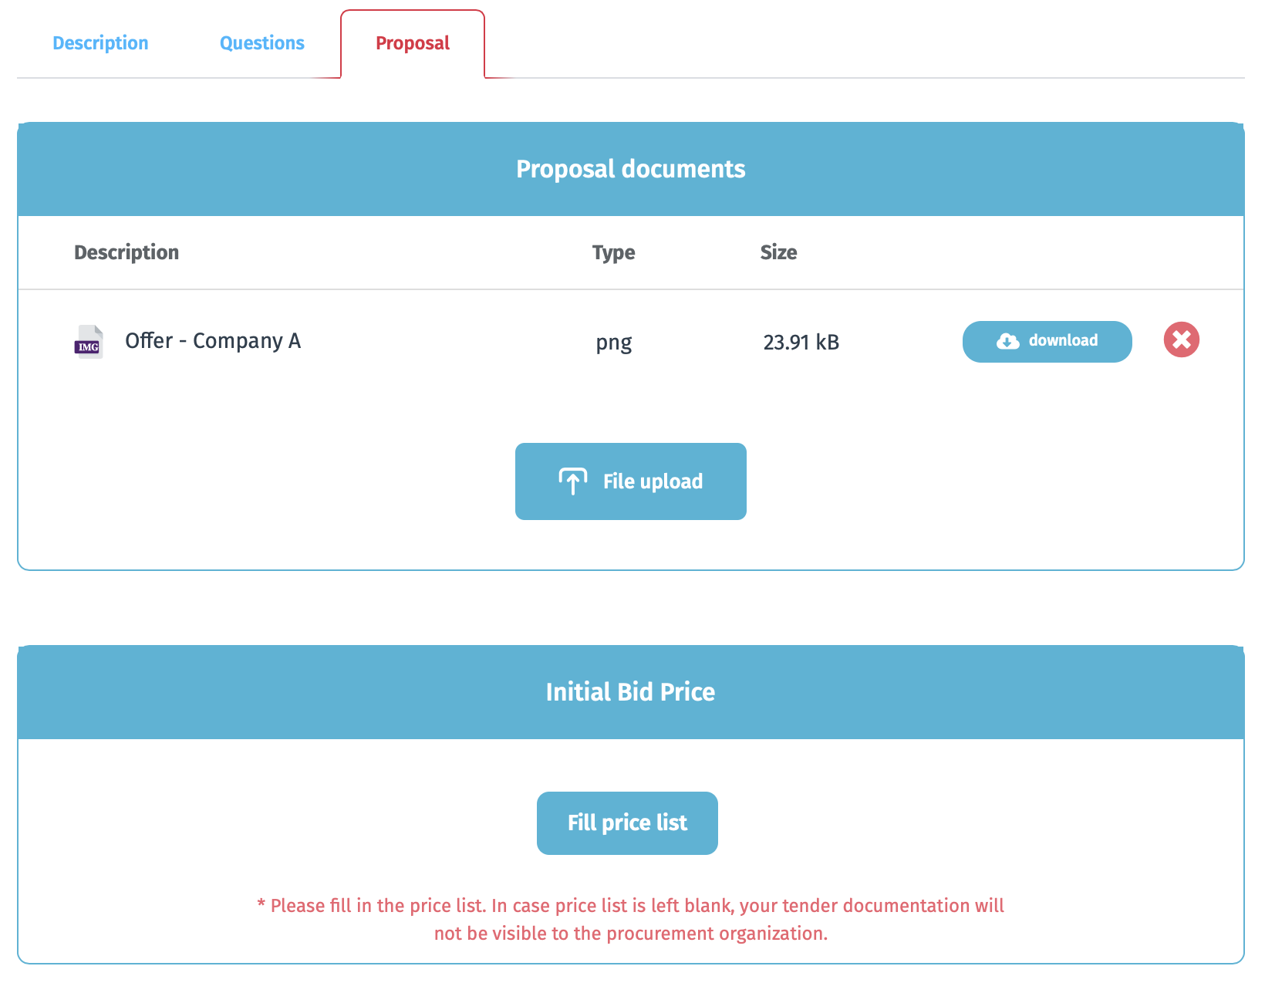 | In case you would like to delete uploaded file, press button “X”.
After pressing the button „Fill price list“, new window will appear where the offer should be submitted. Price list window consists of 2 parts: Positions and Additional info.

Fields to be submitted in the price list table:
- Analogue (Non-mandatory field) - Vendor should fill in the field in case he wants offer the product that differs from the given description;
- Country of origin - Choose from the given list
- Unit price (Total price is calculated automatically by the system)
Note: Open type lock shown at the bottom of the table means that the vendors are not required to submit the bid for all positions.
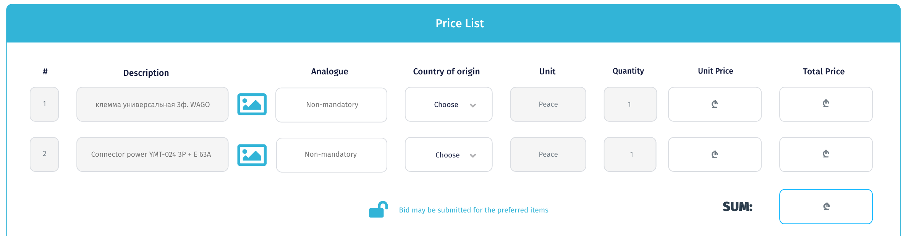
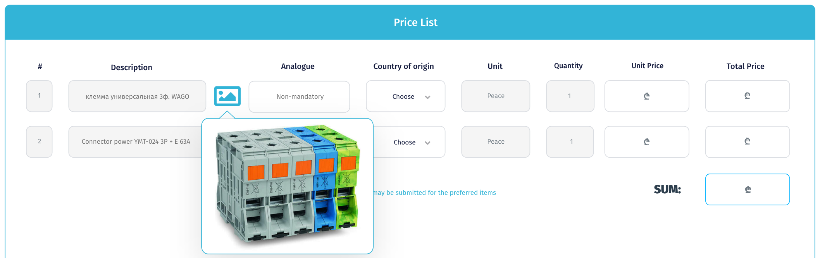

You can review the product photo by pressing the button on the right side of the product description.

Additional info to be submitted:
- Currency - Choose desired currency if it is not fixed;
- Included VAT - Prices should be without VAT. This field is fixed and does not require any action.
- Delivery term - Choose desired delivery term if it is not fixed;
- Delivery time (Days);
- Payment terms - Choose payment term from the provided list;
- Guarantee period (Month) - Choose guarantee period from the provided list;
- Validity period (Days) - Price should be valid for 30 days by default. However the vendor can change it if required.
- Quality certificates - If your products have quality certificate please choose “Yes” and indicate certificate type in the next field.
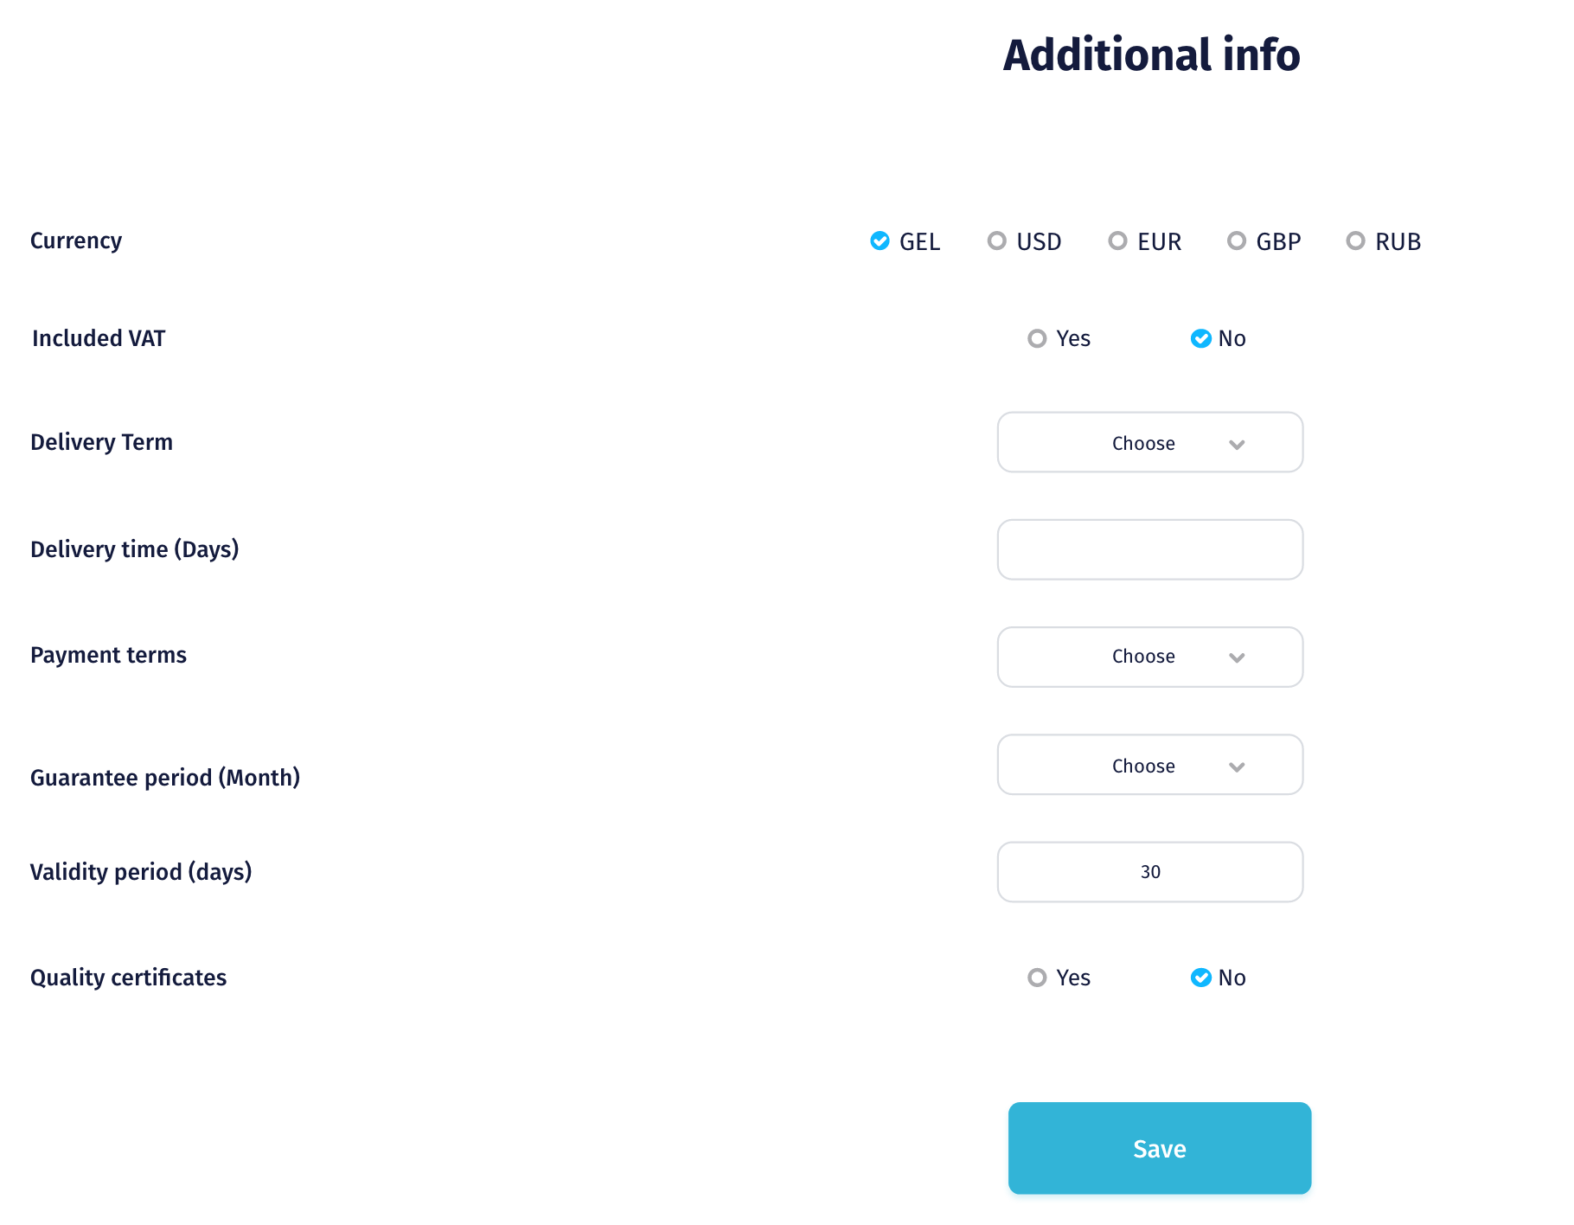

Delivery term:
In case the current field is not fixed by procurer, vendor can make a choice from the provided list:
- DDP Tbilisi
- DDP Zestaponi
- DDP Chiatura
- FAC
- DAP
- CIF
- FOB
- EXW
Note: Please note that each delivery term has its own additional fields that are requested to be filled in by the vendor.

Please review all the possible additional fields below:
- Transportation cost*
- Pickup address*
- Gross weight (kg)*
- Net weight (kg)
- Dimensions*
- HS Code
- Dangerous goods*
- Stackable*
- Lead time (days)*

Payment terms:
Vendor can choose the payment term from the provided list below:
- Advance payment;
- 100% on order readiness;
- 100% on order delivery;
- NET 20;
- NET 30;
- NET 60.

In case of choosing Advance payment, 2 additional fields will appear where the vendor should submit Advance Payment % and Final Payment term. Please note that the maximum advance payment is 50%.

After filling in all the fields please press the “Save” button. System will request confirmation of your bid. After pressing the “Confirm” button your offer will be successfully stored in the system.
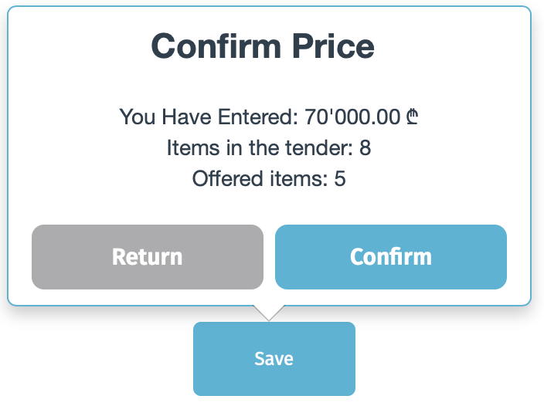

5. Messages
After the tender deadline has passed, tab for messaging is enabled. During the evaluation period procurer and supplier can communicate using messaging tab, so all the exchanged files and information are stored in the system.
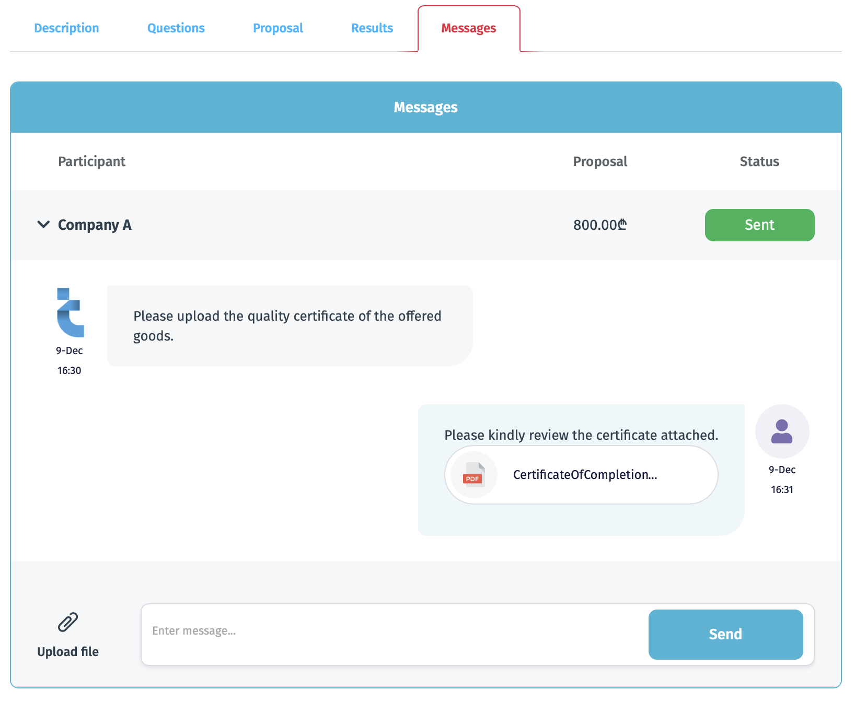
* Please note that the communication can be initiated only by procurer representative.

